EXPERIMENT 5

PROGRAMMING ASSIGNMENT 1

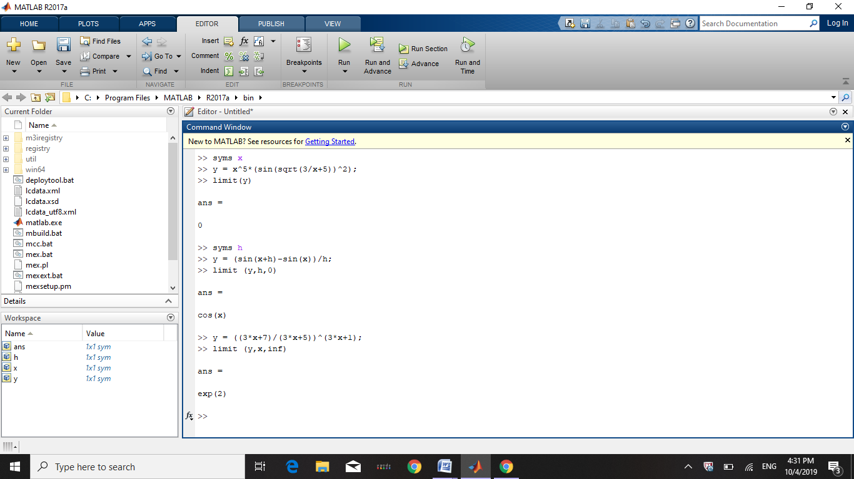

PROGRAMMING ASSIGNMENT 2

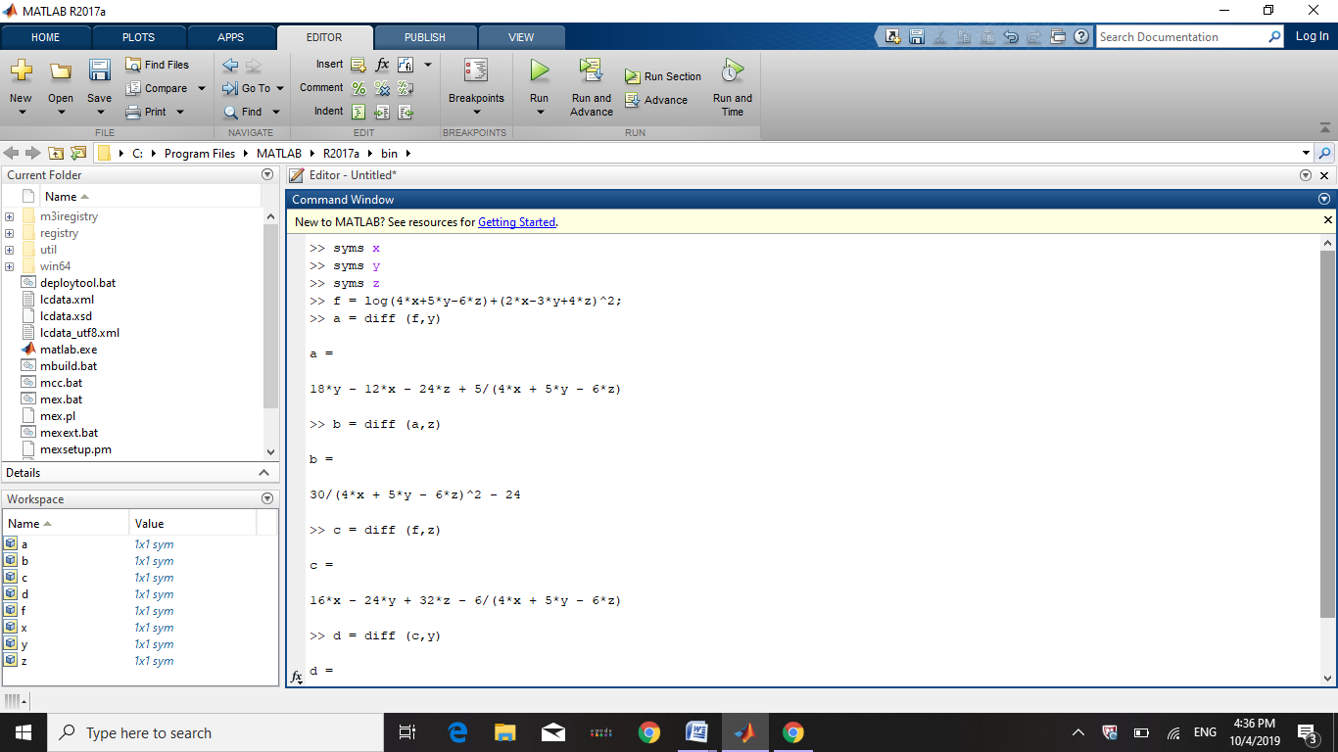

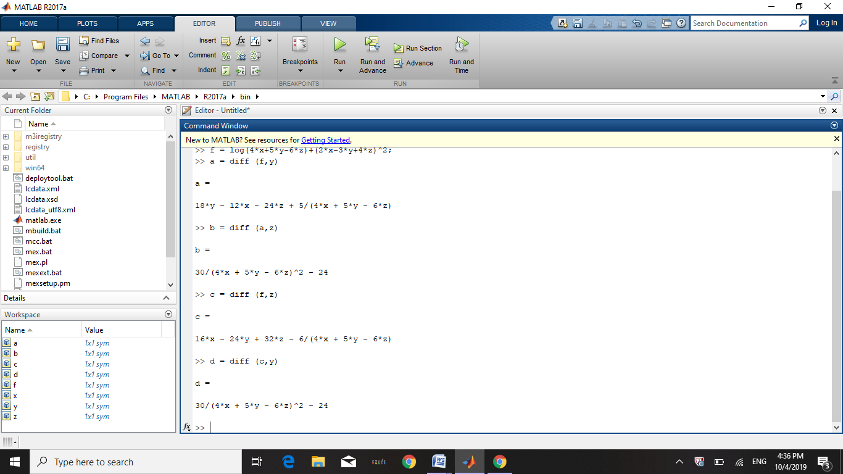

PROGRAMMING ASSIGNMENT 3

